|  |
| --- |
|  |
| User Mannual |
| Mesh Network Based Agriculture Sensing |
|  |
| **Using Esp32+ NRF52840dk+ SIM7600 4G HAT** |
|  |

|  |
| --- |
|  |

**How to Setup Sender nodes?**

**System Components:**

|  |  |  |
| --- | --- | --- |
| **Component** | **Quantity** | **Description** |
| nRF52840 DK | N | Used as **sensor nodes** (senders) and **gateway node** (receiver) |
| Soil Moisture Sensor | N | Connected to nRF nodes via ADC (AIN0, AIN1, AIN2) |
| Solar Panels + Batteries | 1 | Power source for all nodes |

**Setup Instructions:**

**1-** Download SEGGER's Embedded Studio, [Click Here.](https://www.segger.com/products/development-tools/embedded-studio/)

2. Connect NRF Board to your pc using USB.

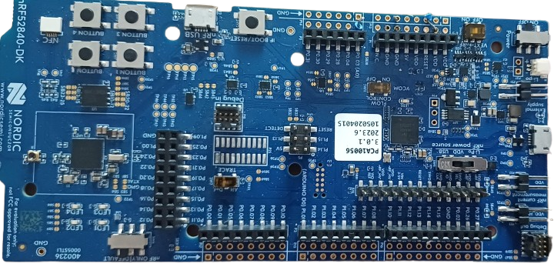

**🡪 To PC.**

3. After connecting to your pc, ignore the pop up and LED start glowing in NRF board.



4. Open the folder “nrf_sdk – Copy-> examples ->My projects -> cli_sender (saadc) -> ftd-> uart-> pca10100-> blank-> ses” and open .”emProject” file.

5- In **SEGGER's Embedded Studio go to “Target->Connect J-Link”.**

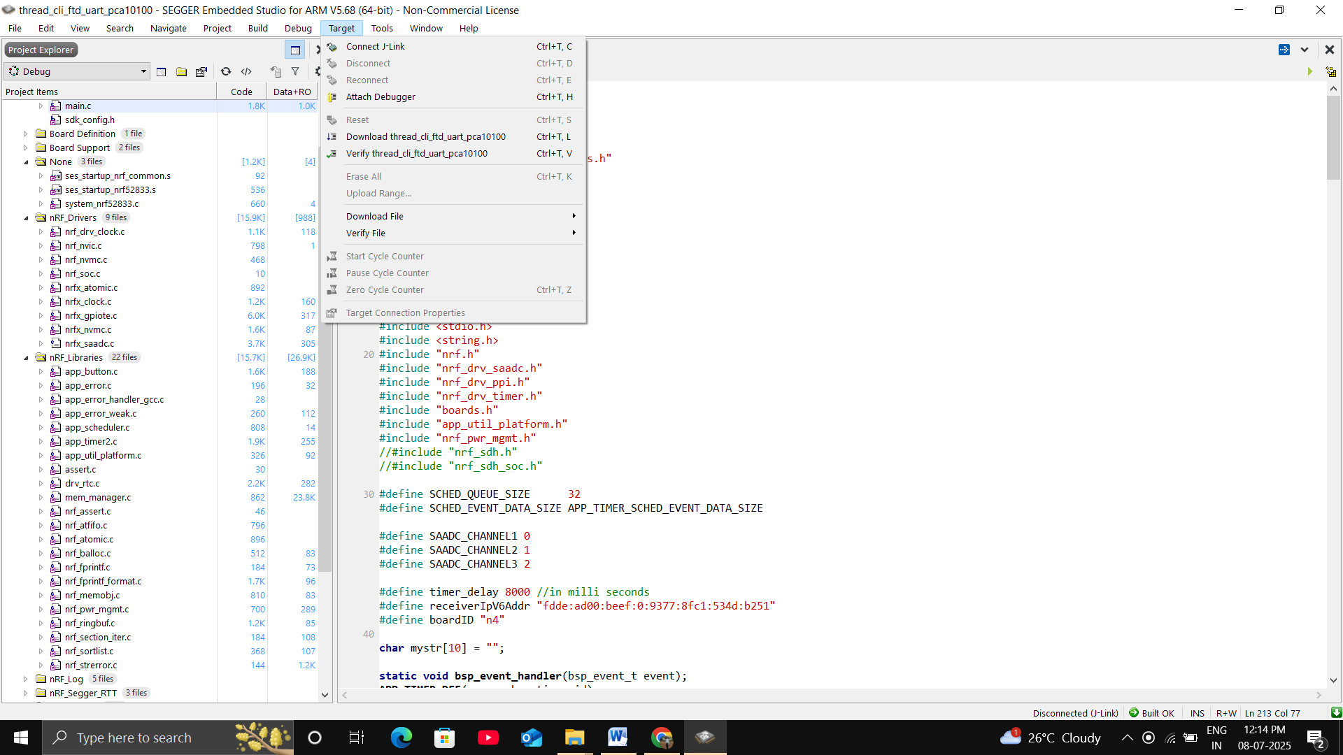

6- Go to “Build tab-> Build and Run”

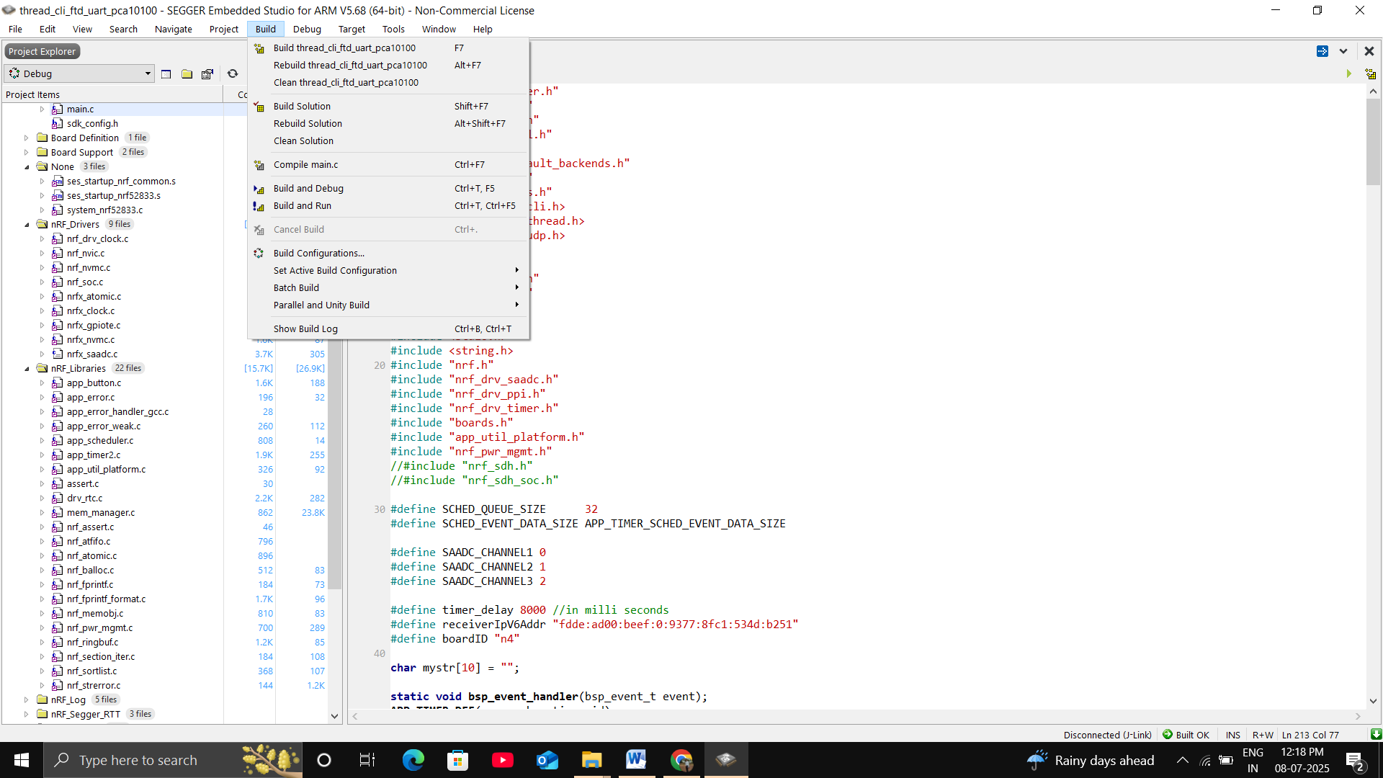

This will compile the code and after compiling successfully we will see a popup while writing the flushing the code.

**How to Verify that flushing is successful?**

**1- Connect Nrf board to your pc.**

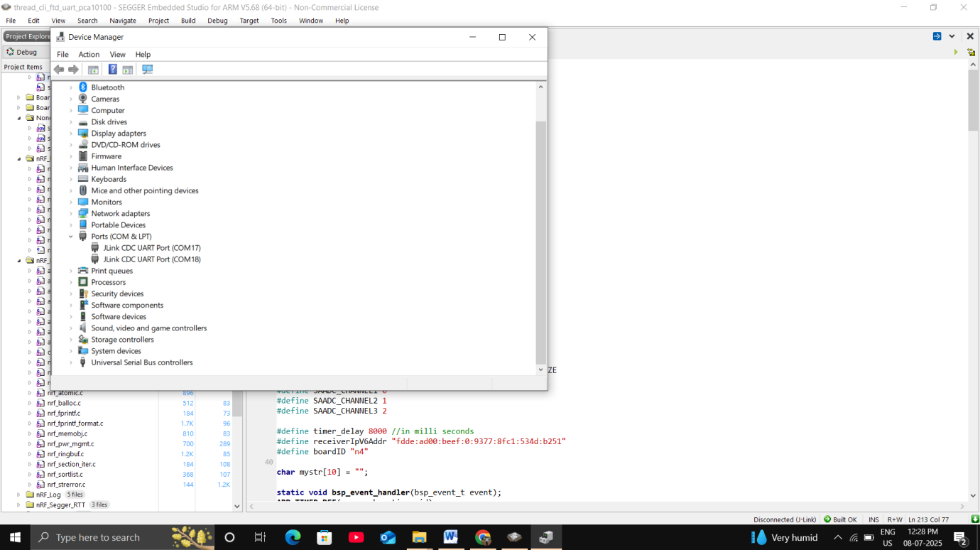**2- Using device manager find the port to which NRF baord is connected.**

Ports COM17 and COM18 is being used by NRF board, it may vary so check ports for your pc.

3- Open Putty:

* Connection Type:- Serial
* Serial Line: COM17(Change it according to the port being used by NRF board in your pc)
* Speed: 115200
* 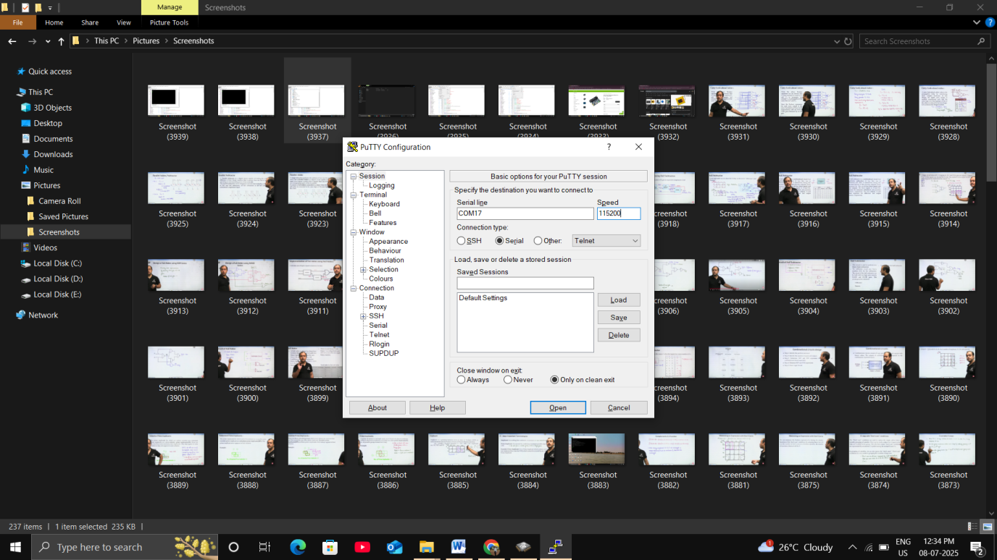Click Open.

In putty terminal we will see “Done” printing after every 8 second.

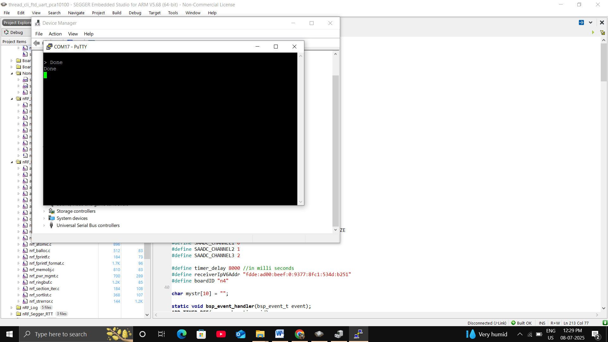

**How to connect sensors to board?**

**1- Connect soil moisture sensors to sensor connector module.**

We can connect any pin of connector module to any wire of sensor(there is no +/- polarity)

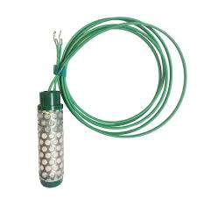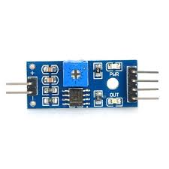

2- Connector above module to NRF board.



VCC

VDD

A0

P0.03

GND

P0.02

P0.04

We can connect another sensor to P0.02 and P0.04

**How to Setup Receiver?**

## System Components:

|  |  |  |
| --- | --- | --- |
| **Component** | **Quantity** | **Description** |
| nRF52840 DK | 1 | Used as sensor nodes (senders) and gateway node (receiver) |
| ESP32 | 1 | Collects data from gateway nRF and sends to SIM7600 |
| SIM7600 Module | 1 | Sends HTTP data to a cloud relay which logs to Google Sheets |
| Solar Panels + Batteries | 1 | Power source for all nodes |

**Setup Instructions:**

**1-** Download SEGGER's Embedded Studio, [Click Here.](https://www.segger.com/products/development-tools/embedded-studio/)

2. Connect NRF Board to your pc using USB.



**🡪 To PC.**

3. After connecting to your pc, ignore the pop up and LED start glowing in NRF board.



4. Open the folder “nrf_sdk – Copy-> examples ->My projects -> cli_Receiver -> ftd-> uart-> pca10100-> blank-> ses” and open .”emProject” file.

5- In **SEGGER's Embedded Studio go to “Target->Connect J-Link”.**



6- Go to “Build tab-> Build and Run”



This will compile the code and after compiling successfully we will see a popup while writing the flushing the code.

**How to verify that flushing is successful?**

**1- Connect NRf board to your pc.**

**2- Using device manager find the port to which NRF board is connected.**

Ports COM17 and COM18 is being used by NRF board, it may vary so check ports for your pc.

3- Open Putty:

* Connection Type:- Serial
* Serial Line: COM17(Change it according to the port being used by NRF board in your pc)
* Speed: 115200

In putty terminal we will see like ‘’Received UDP Data: 1234:234:123:34::n1”.

* Click Open.

Where “n1” is the name of node.

“1234” is the port number

“234” is the sensor A Value which is connected to P0.02 in sender board

“123” is the sensor B Value which is connected to P0.03 in sender board

“34” is the sensor C Value which is connected to P0.04 in sender board

**How to change Google sheet?**

1- Go to [Google Sheets](https://sheets.google.com).

2-Click **"Blank"** to create a new spreadsheet.

3- Give it a name like mesh_data.

4- In your new sheet, click: **Extensions > Apps Script**

5- Replace the default code with this basic script:

function doGet(e) {

var sheet = SpreadsheetApp.getActiveSpreadsheet().getActiveSheet();

// Get parameters from request

var hum = e.parameter.hum;

var humi = e.parameter.humi;

var humii = e.parameter.humii;

var name = e.parameter.name;

// Get current date and time separately

var now = new Date();

var currentDate = Utilities.formatDate(now, Session.getScriptTimeZone(), "yyyy-MM-dd");

var currentTime = Utilities.formatDate(now, Session.getScriptTimeZone(), "HH:mm:ss");

// Append a new row

sheet.appendRow([currentDate, currentTime, name, hum, humi, humii]);

return ContentService.createTextOutput("Data logged");

}

**If Google do not authorize your script then:**

* Google will show a warning: “Google hasn’t verified this app”
* Click Advanced
* Click "Go to Your Project (unsafe)"
* Click Allow

6- Click Deploy > Manage deployments > New deployment

* Select "**Web App**"
* Execute as: **Me**
* Who has access: **Anyone**

7-Click **Deploy**, then **Authorize**, and you’ll get a **public Web App URL**, something like:

[*https://script.google.com/macros/s/AKfycbzo7fIXD77pvr3BR-zbSJvrskjFvrt35SUJX1_buR-2FSs36G4aStMcIq3wce2CcvPSeQ/exec*](https://script.google.com/macros/s/AKfycbzo7fIXD77pvr3BR-zbSJvrskjFvrt35SUJX1_buR-2FSs36G4aStMcIq3wce2CcvPSeQ/exec)

8- Login to [*pythonanywhere.com*](http://www.pythonanywhere.com)

* Username:- mesh
* Password:- mesh@8931

Step 9

We will see a dashboard like this:-

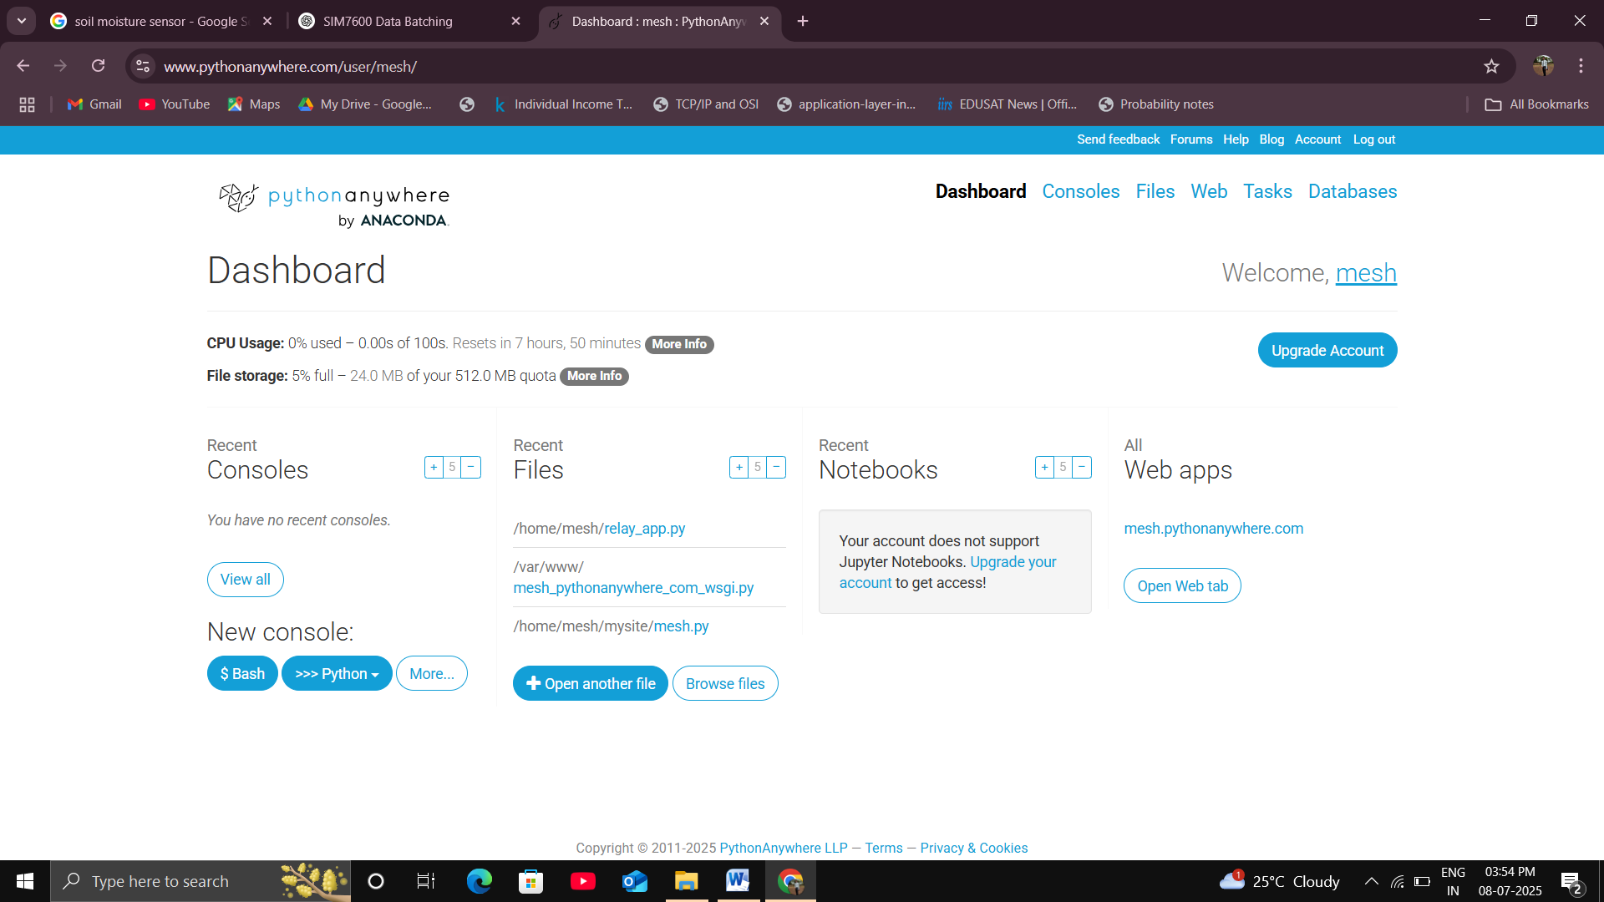

9- Go to Files tab.

10. Open “relay_app.py “ file.

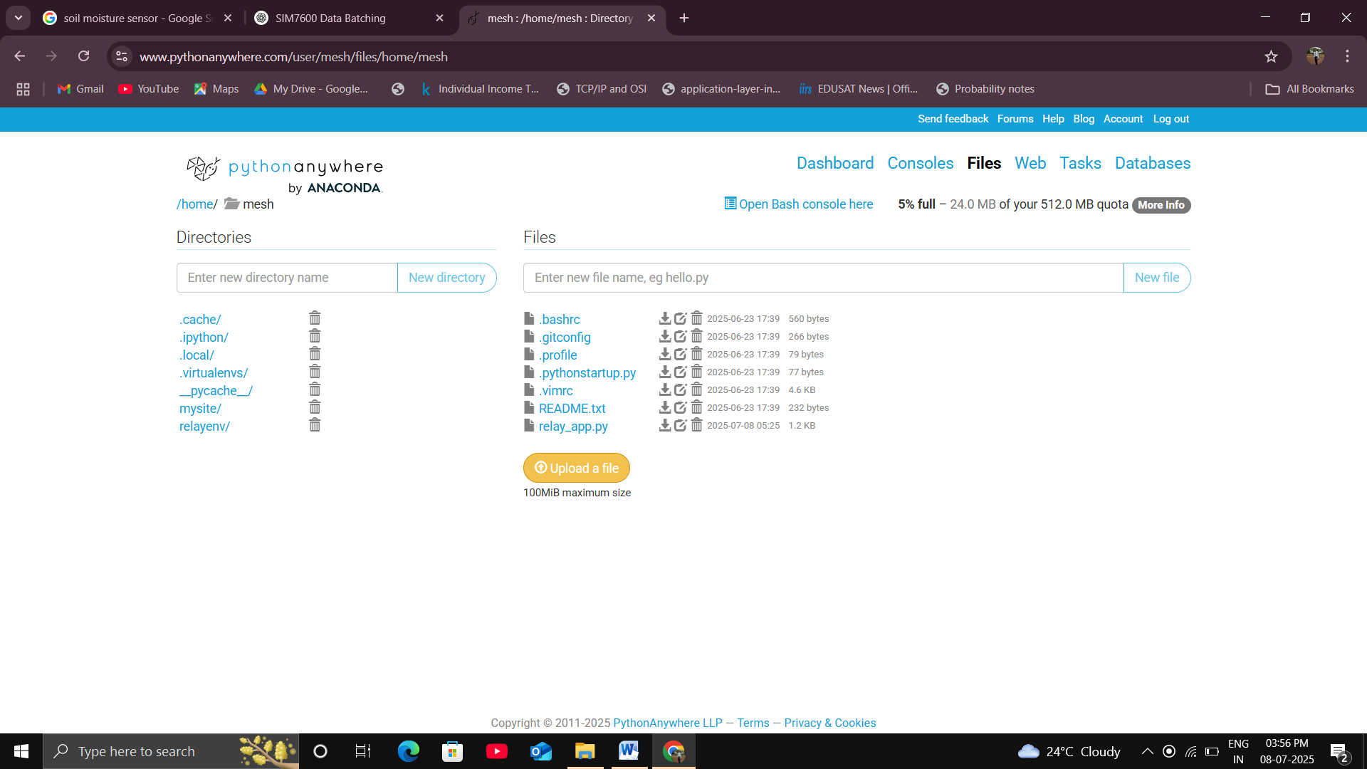

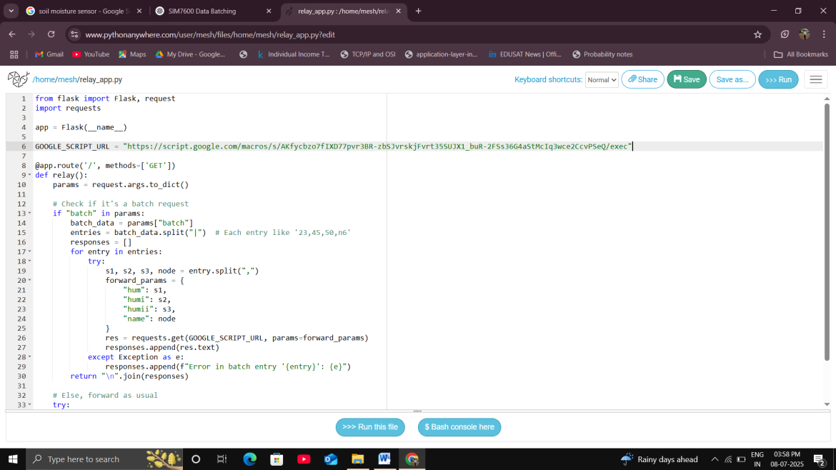11- Change the Google Script url with new one got in step 7.

12- Go to Web Tab.



13- Reload the Web Tab.

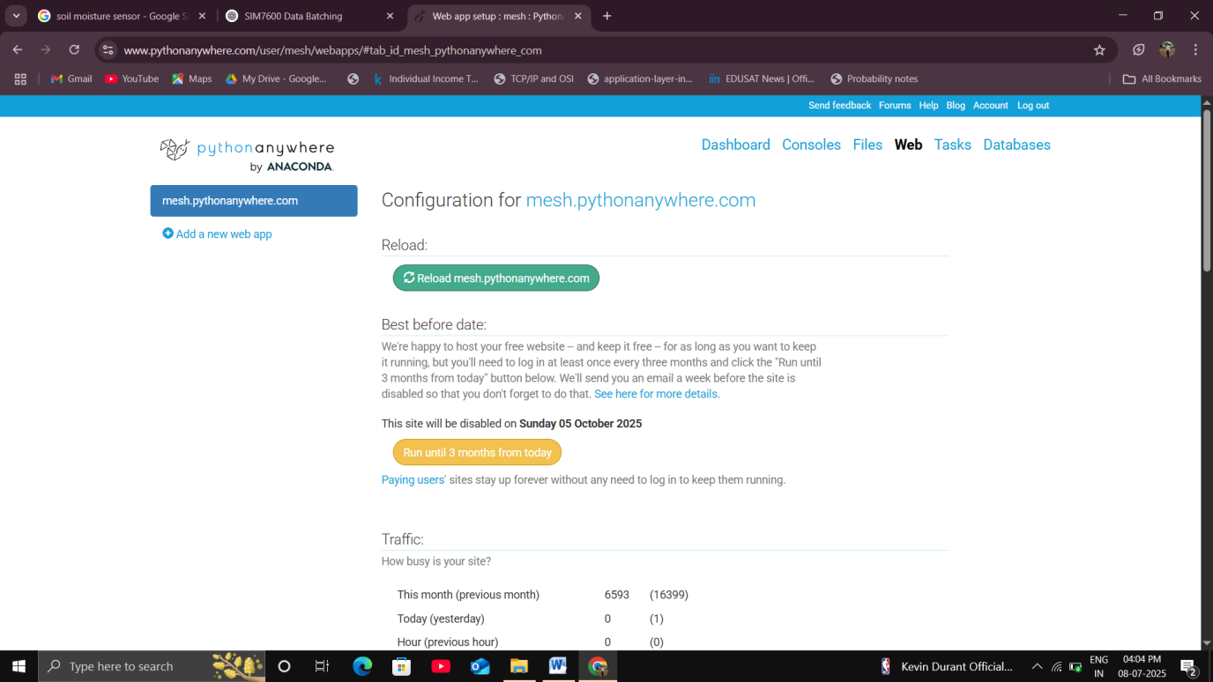

14- In your browser open:-

<http://mesh.pythonanywhere.com/?batch=23,45,50,test|25,47,49,test>

We will see two new rows be added in new Google sheet with node_name as “test”.